This is a stability calculator for Digital Linear Ion Trap programmed in Visual Basic, called “DAWI calculator for LIT”. This software can be used to compute a-q parameters at boundaries of the first stability region, and to predict the stability of ions with given mass-to-charge ratios (m/z) and parameters of the rectangular waveforms.

The constant:
The inscribe radius r₀ = 10 mm. For other size of quadrupole, simply rescale the voltage in proportion to the r₀^2. For example, enter 4 times of voltage if your inscribe radius is 5 mm.

Setting parameters for the waveform:
Mass, means the mass to charge ratio in unit Th.
Voltage [V0-p], the amplitude of the rectangular wave, assuming the rectangular wave is generated by switching between + and - [V,0-p].
DC offset，the supplement dc voltage applied between the x and y poles, set as a percentage of the [V,0-p]. This voltage is normally omitted in the DLIT, ie., 0%, because the dc quadrupole component can be generated by selecting duty cycle alone.

Graphical display:
This is just a conceptual indication window, showing the four boundaries of the 1st stability region:
Light blue: βx = 0
Blue: βx = 1
Red: βy = 0
Brown: βy = 1
When Calculation button is pressed, a scan line will be shown in the graphic window, and the table displays the a_{x}, q_{x} parameters at the stability boundary points intersected by the scan line. Whichever color of the stable boundary the scan line intersects, the a_{x}, q_{x} values will be shown in the column with corresponding color, along with the periods of the rectangular wave when these points are reached.

A rectangular wave period used in the experiment can also be manually entered into the table, and pressing the [exp. Correction] button will then yield the a_{x}, q_{x} values corresponding to this period in the same column.

The basic use of the calculator
Mapping stability diagram: This calculator allows obtaining the a_{x}, q_{x} values (coordinates) on the stability boundary by stepping up/down the duty cycle values, and using these coordinates to plot a stability diagram. Such a stability diagram is generated for the pure digital ion trap where the resolving dc is only generated by the duty cycle. Alternatively, by fixing duty cycle and gradually adjusting the percentage of DC offset, (another way to change the scan line slope) the a_{x}, q_{x} coordinates at the boundary points can also be obtained.

Calculation of DAWI window: Using a duty cycle greater than 0.5, the coordinates of both ends of the scan line intercepted by the by = 0 and bx = 1 stability boundaries are given. The corresponding mass isolation range can be obtained by comparing the two q_{x} values.

More details may be found in the paper:
Li Ding, Lulu Sun, Weimin Wang, The development of the digital ion trap mass spectrometry reviews. 2025 ????
If you find this software useful, we ask that you please cite the paper. We welcome the submission of bugs, improvements, and suggestions to the software.
The software will be further enhanced to incorporate other configurations of ion traps.

Example one:
When the d = 0.5 (shown in Fig. 1), the working points of all ions sit on the -axis, and = 0.712 is the low mass cut-off (LMCO) point corresponding to the stability boundaries in both the x- and y-directions.
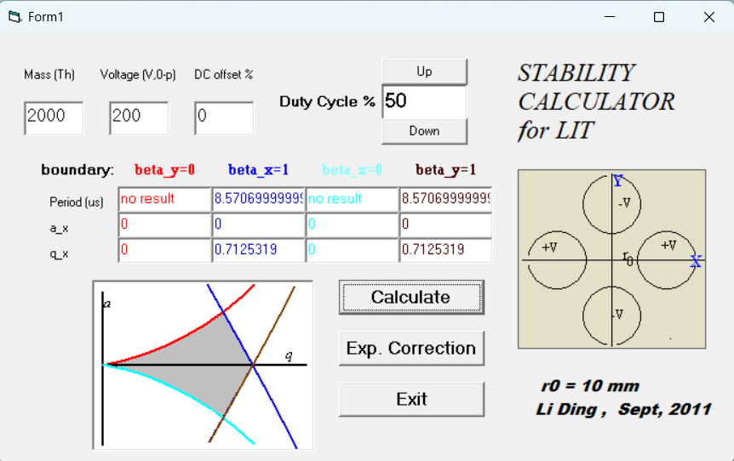
Fig. 1
The apex of the first stability region is located at ( = 0.561, =±0.265) and to reach this point the duty cycle of the waveform needs to be 0.388 (Fig. 2) or 0.612 (Fig. 3).
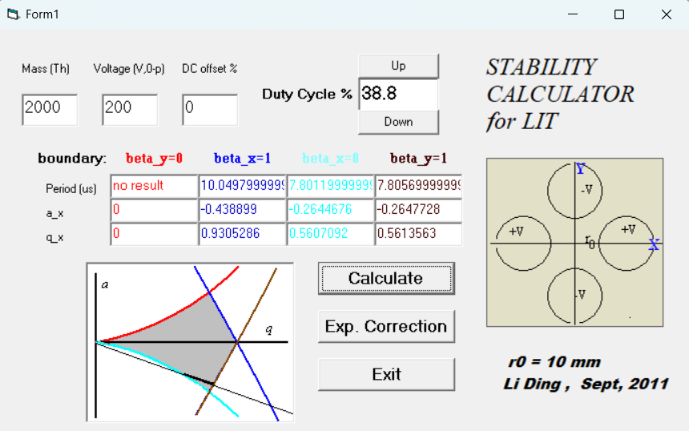
Fig. 2
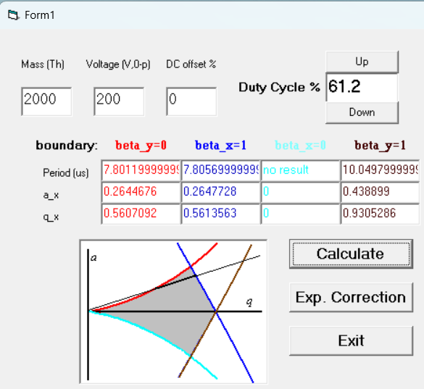
Fig. 3
if I want isolate m/z 2000 ions at V_{0-p}=200 V, duty cycle at 60.9375 (as shown in the Fig. 4), then the period should be 7.6943<T<7.8187.
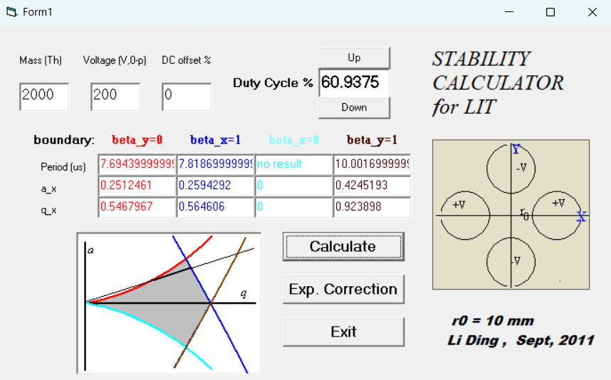
Fig. 4

Example two: For a given m/z, trapping potential, and d, the software can calculate the required digital wave period for which the ion is theoretically brought to specific stability boundaries for the 1st stability region.
As shown in Fig. 5, when m/z is 2000, the digital square wave voltage V_{0-p} is 200 V with a 50 % duty cycle. The theoretical digital rectangular wave period should be ~8.5706999 μs. Therefore, the initial period (T_{start}) should be less than 8.5706999 μs to scan ions to the right.
This function applies to forward or reverse scanning of the digital ion trap.
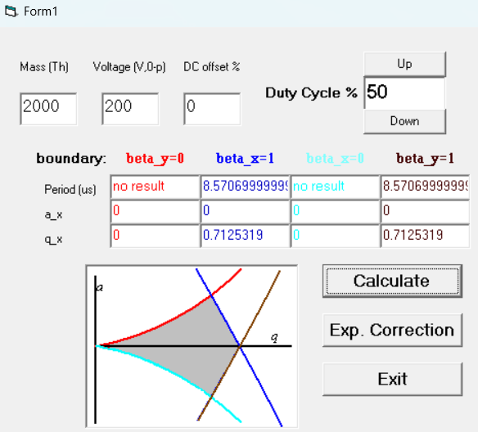
Fig. 5
As shown in Fig. 6, when the duty cycle changes to 45 %. For forward scan, the T_{start} should meet 5.0461<T_{start}<9.1075.
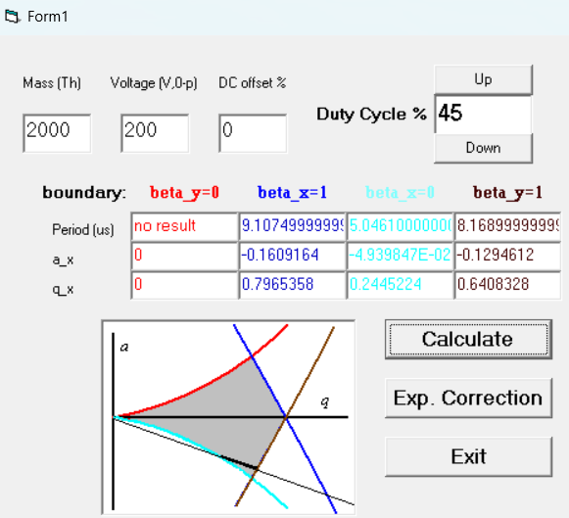
Fig. 6

